|  |  |
| --- | --- |
| **Lab Number:** | **1** |
| **Student Name:** | **Rohit Gupta** |
| **Roll No :** | **30** |

# Title:

To Add Two Numbers, Print Number Entered by User, Swap Two Numbers, Check Whether Number is Even or Odd

* 1. Implement using C++
  2. Implement using Java

# Learning Objective:

* + - Students will be able to write C++ and java program for simple arithmetic operations and take input from user.

# Learning Outcome:

* + - * Ability to execute a simple C++ and Java program with and without any inputs to the program.
      * Understanding the constructs in C++ and Java.

# Course Outcome:

|  |  |
| --- | --- |
| **ECL304.1** | Understand object-oriented programming concepts and implement using C++ and Java |

**Theory:**

**Difference between procedural and object oriented language Application of object orientation**

**Brief introduction to C++ and Java**

|  |  |
| --- | --- |
| **Algorithm :** |  |
| **Program:** |  |
| **Input given:** |  |
| **Output Screenshot:** |  |

**C++ PROGRAMS**

1. **TO ADD TWO NUMBERS ALGORITHM:**

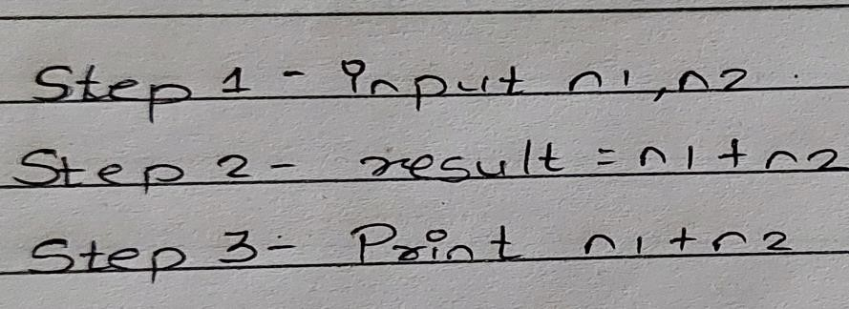

**PROGRAM:**

//To Add Two Numbers #include<iostream> using namespace std; int main()

{

int n1,n2,result; n1=10;

n2=5;

result=n1+n2;

cout << n1 << " + " << n2 << " = " << result; return 0;

}

# OUTPUT SCREENSHOT:

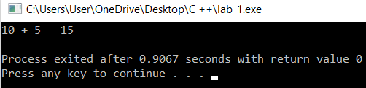

1. **TO PRINT NUMBERS ENTERED BY USER ALGORITHM:**

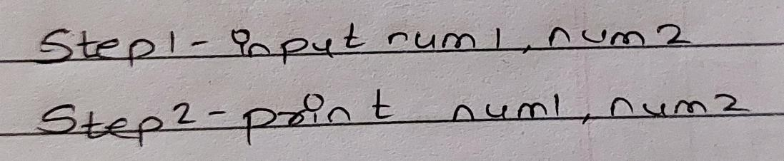

**PROGRAM:**

// Print Number Entered by User #include<iostream>

using namespace std; int main()

{

int num1,num2;

cout<<"\n Enter 2 numbers"; cin>>num1>>num2;

cout<< " Entered numbers are:" << num1<< " " << num2; return 0;

}

# OUTPUT SCREENSHOT:

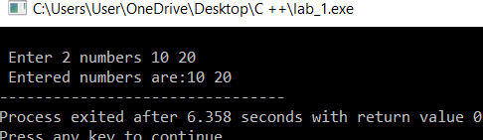

1. **TO SWAP TWO NUMBERS ALGORITHM:**

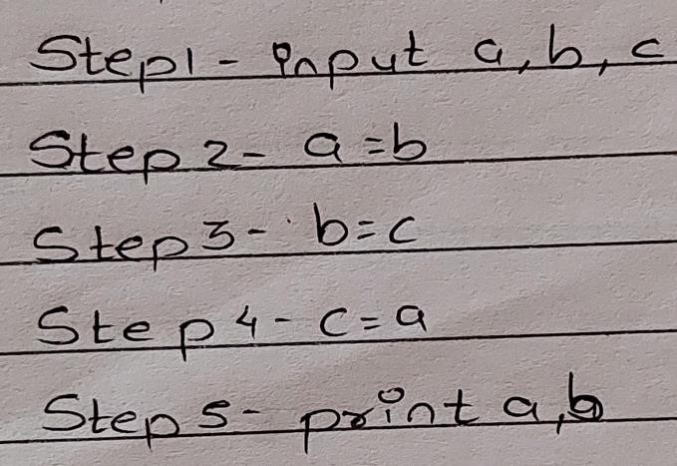

**PROGRAM:**

//Swap Two Numbers

#include<iostream> using namespace std; int main()

{

int a,b,c;

cout<<"\n Enter two no to swap:"; cin>>a>>b;

c=a; a=b; b=c;

cout<<"\n Swapping the numbers: \n"; cout<<" a= "<<a<<" b= "<<b;

return 0;

}

# OUTPUT SCREENSHOT:

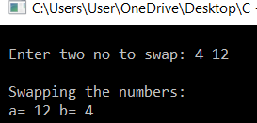

1. **TO CHECK WHETHER NUMBER IS EVEN OR ODD ALGORITHM:**

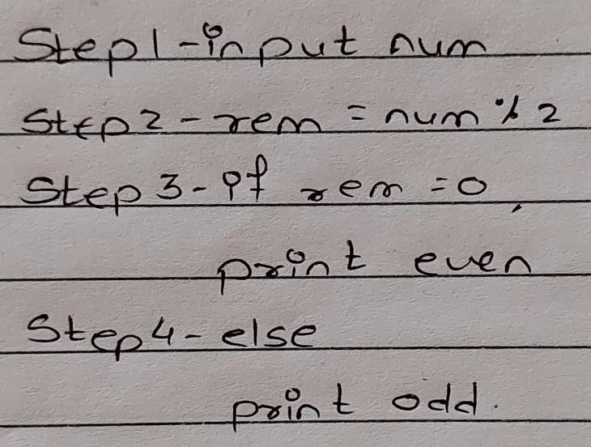

**PROGRAM:**

//To check whether no is even or odd

#include<iostream> using namespace std;

int main()

{

int num=5;

cout<<"\n Number is"; cin>>num;

if ( num % 2 == 0) cout<<num<<" is even"; else

cout<<num<<" is odd";

}

# OUTPUT SCREENSHOT:

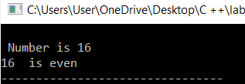

**JAVA PROGRAMS**

1. **TO ADD TWO NUMBERS ALGORITHM:**

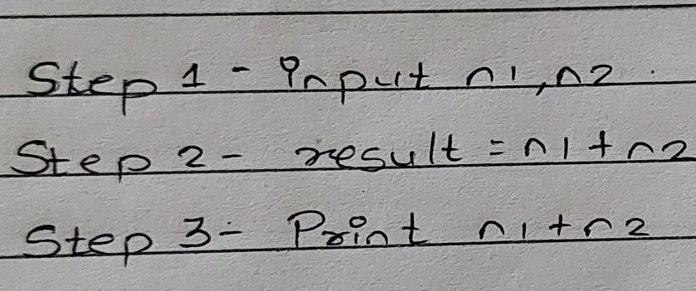

**PROGRAM:**

//To Add Two Numbers public class Main{

public static void main(String[] args){

int x = 5; int y = 6;

int sum = x + y ; System.out.println("x + y =" +sum);

}

}

# OUTPUT:

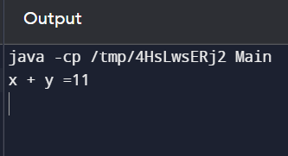

1. **TO PRINT NUMBERS ENTERED BY USER ALGORITHM:**



**PROGRAM:**

import java.util.Scanner; public class Lab1 {

public static void main(String[] args) { Scanner sc = new Scanner(System.in); int n1,n2,temp;

System.out.println("Enter first number"); n1=sc.nextInt();

System.out.println("Enter second number"); n2=sc.nextInt();

System.out.println("Numbers are "+n1 +" " + n2);

}

}

# OUTPUT:

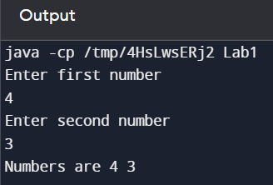

1. **TO SWAP TWO NUMBERS ALGORITHM:**



**PROGRAM:**

//to swap two numbers

import java.util.Scanner; public class Lab1 {

public static void main(String[] args) { Scanner sc = new Scanner(System.in); int n1,n2,temp;

System.out.println("Enter first number"); n1=sc.nextInt();

System.out.println("Enter second number"); n2=sc.nextInt();

System.out.println("\n SWAPPING\n"); temp=n1;

n1=n2; n2=temp;

System.out.println("After swapping Number 1 = "+n1+" Number 2 = "+n2);

}

}

# OUTPUT:

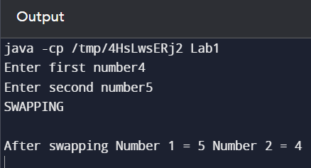

1. **TO CHECK WHETHER NUMBER IS EVEN OR ODD ALGORITHM:**



**PROGRAM:**

//to check whether no is even or odd. import java.util.Scanner;

public class Lab1 {

public static void main(String[] args) { Scanner sc = new Scanner(System.in); int n1,n2,temp; System.out.println("Enter a number:"); n1=sc.nextInt();

System.out.println("\n EVEN/ODD\n");

if(n1%2==0)

System.out.println(n1+" is Even"); else

System.out.println(n1+" is Odd");

}

}

# OUTPUT:

